OFFICIAL COORDINATION REQUEST FOR NON-ROUTINE OPERATIONS AND MAINTENANCE

COORDINATION TITLE- 23JDA37 MOC Early Outage Request for SMF Winter Maintenance
COORDINATION DATE- 26 October 2023
PROJECT- John Day Dam

RESPONSE DATE- 9 November 2023

Description of the problem

The John Day Project is requesting to dewater the Smolt Monitoring Facility (SMF) on 30 November 2023 (1-day before the winter maintenance season). The SMF dewatering would be performed in the afternoon making the outage <12-hours early. The 1st day of winter maintenance (1 December 2023) falls on a Friday, which is a weekend for the JDA project. The following Monday (4 December 2023) will be spent dewatering the South Fish Ladder (SFL). Dewatering the SMF early allows more time for winter maintenance. It also prevents equipment damage if temperatures drop below freezing.

Dewatering the SMF early will not affect downstream fish passage. The STSs will continue running and the Juvenile Bypass System (JBS) as a whole would be unchanged. The only difference would be losing PIT detections during that time. Most years there are no PIT detections from 30 November (12PM – proposed outage time) to 1 December (8AM-time when SMF would normally be dewatered) and in the past 10-years there have been 4-total detections during that time (see Table 1).

Note: SMF dewatering is performed by raising the crest gate. All fish would bypass the Primary Dewatering Structure (PDS), Full-flow PIT detectors, and the switch gate. The fish would instead travel down the ogee chute, through an underground channel, and exit via the same outfall chute (see Figure 1).

 | Chinook | Coho
2013 | 1 | 0
2014 | 0 | 0
2015 | 0 | 0
2016 | 0 | 0
2017 | 0 | 0
2018 | 0 | 0
2019 | 0 | 0
2020 | 0 | 0
2021 | 1 | 1
2022 | 1 | 0

Table 1: PIT detections at the SMF full-flow detectors from 30 November @ 12PM to 1 December @0800 (years 2013-2022).

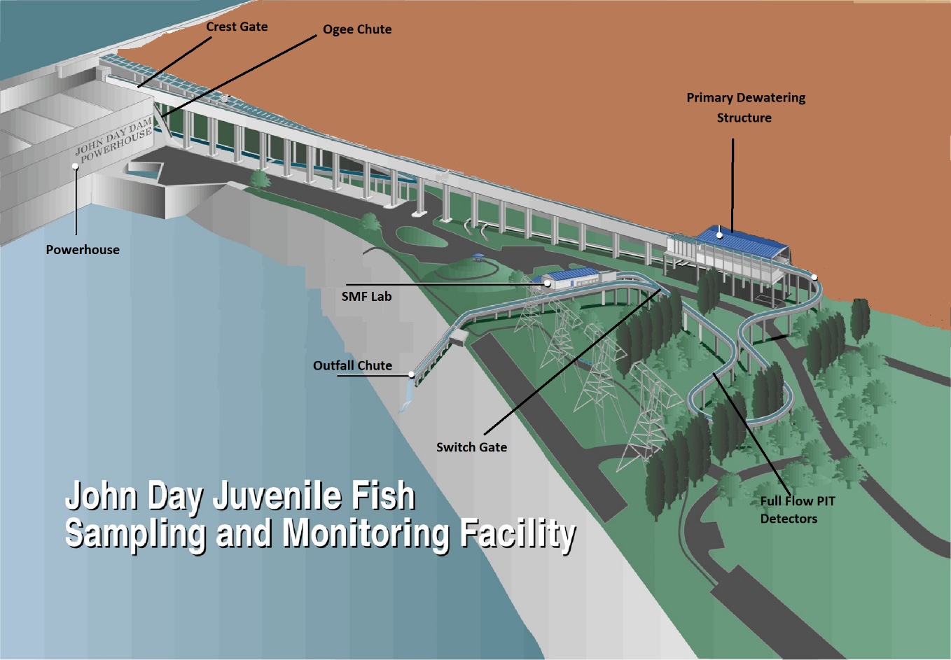
Figure 1: Overview of John Day Smolt Monitoring Facility

Type of outage required

Impact on facility operation: The JBS system would be unchanged, and all fish bypassed by STS would get diverted directly into the river bypassing the SMF entirely.

Impact on unit priority: There would be no impact on unit priority.

Impact on forebay/tailwater operation: There would be no impact on forebay/tailwater operation.

Impact on spill: There would be no impact on spill.

Dates of impacts/repairs: 30 November 2023 at ~12PM – 1 December 2023.

Length of time for repairs: N/A

Analysis of potential impacts to fish: There would be no impact on fish, as all fish would still be diverted directly back into the river.

Summary statement - expected impacts on:

Downstream migrants: There are few if any downstream migrants and smolt monitoring concluded September 15th.

Upstream migrants (including Bull Trout). No impacts on upstream migrants as the ladders will be unaffected.

Lamprey. There should me no impacts on lamprey as the spring freshet is long past.

Comments from agencies

Please email or call with questions or concerns. Thank you,

Tammy Mackey
Columbia River Coordinator
503-961-5733

Eric Grosvenor
Chief of Fisheries
John Day Dam
Eric.Grosvenor@usace.army.mil

